Course Name:  Course Code: | Digital Logic Design Laboratory (DLDL)  316U06L202 | Semester: | II
Date of Performance: | 1 / 04 /2026 | Batch No: | A1
Student Name: | Arav Arun | Roll No: | 16010125013
Faculty Sign & Date: |  | Grade/Marks: | / 2
Experiment No: 10
Title: Implementation of 4-bit Serial-In Parallel-Out Shift Register
Aim and Objective of the Experiment:
Implementation of 4-bit Serial-In Parallel-Out Shift Register using V-LAB.. Design and implement sequential logic circuits and their applications

COs to be achieved:
CO4: Implement sequential logic circuits and applications using MSI devices.
CO5: Understand basic principles required for advanced Digital Design

Use the following link to implement and verify the above circuit Virtual Labs (vlabs.ac.in)
Pin Diagram: D-FF IC 7474
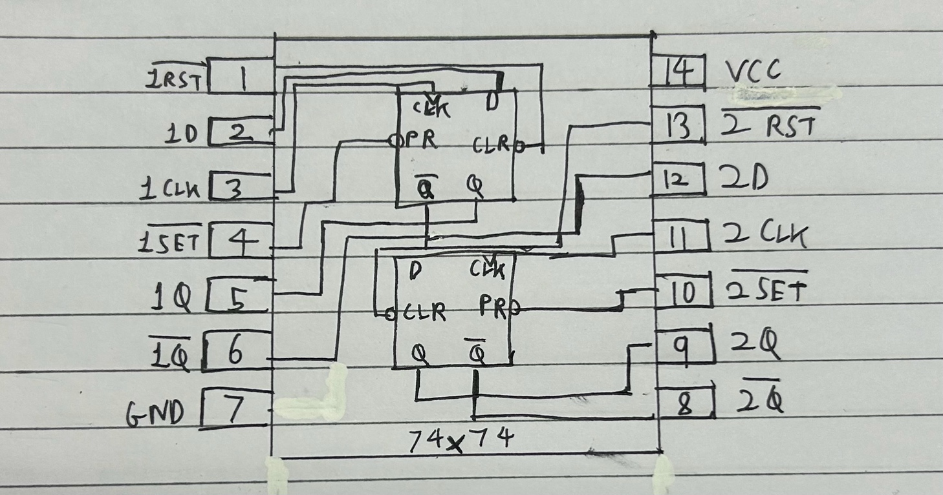

Logic Diagram: 4-bit synchronous counter
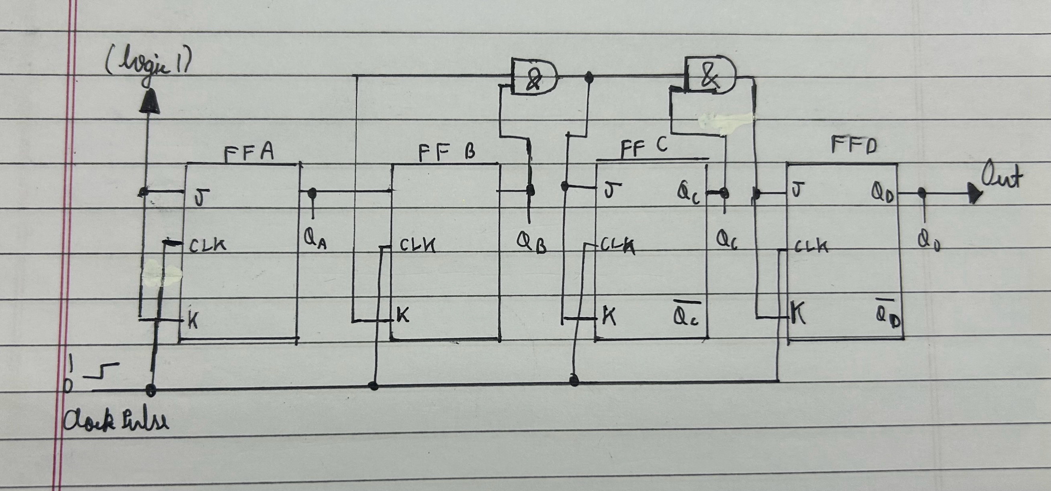

Screenshot of the diagram from VLAB
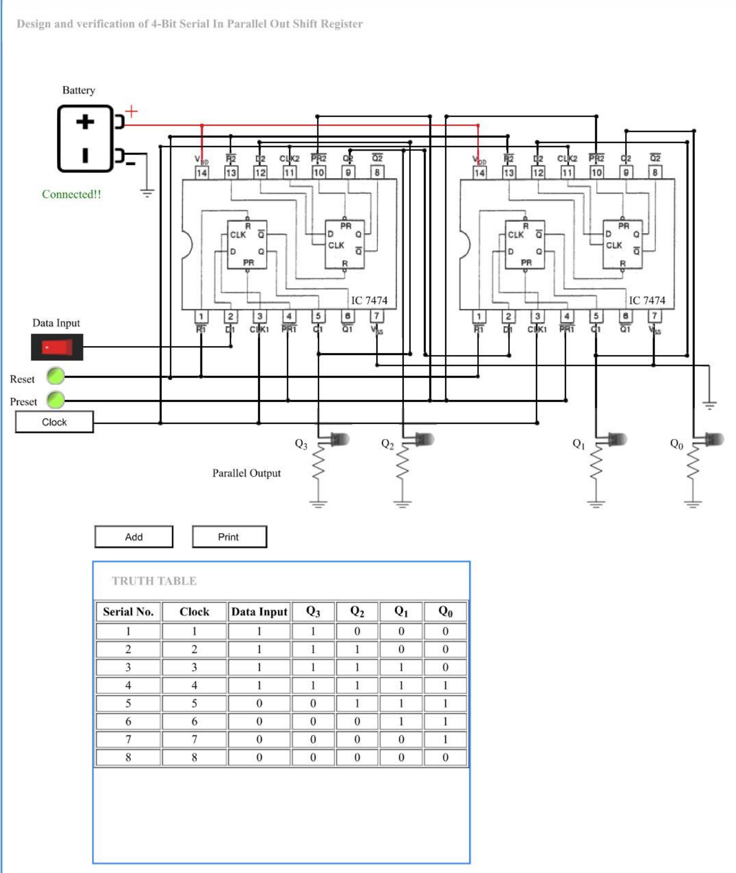

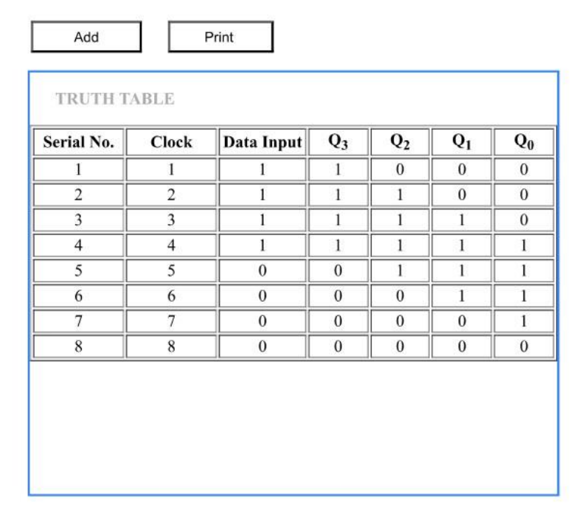
Conclusion:
The experiment on implementing a 4-bit Serial-In Parallel-Out (SIPO) shift register using V-LAB was successfully completed, demonstrating the working of sequential logic circuits. It helped in understanding how data is entered serially and becomes available in parallel form after successive clock pulses. The observed results matched the expected output, confirming the correct operation of the shift register. This experiment strengthened concepts such as flip-flop operation, clock-based data transfer, and synchronization, while also highlighting the practical applications of shift registers in digital systems for data storage, transfer, and serial-to-parallel conversion.

Signature of faculty in-charge with Date:

